**MILESTONE # 3**



**CSE-403L**

**Database Management System Lab**

**GROUP MEMBERS:**

**OMER KHAN (22PWCSE2130)**

**NAVEED AHMED (22PWCSE2165)**

**JAMAL KHAN (22PWCSE2203)**

**Section: B**

“On my honor , as student of University of Engineering and Technology, I have neither given nor received unauthorized assistance on this academic work”

Signature: _____________________________________ Date: June 2, 2025

**Submitted To: Engr. Sumayyea Salahuddin**

**Department of Computer Systems Engineering University of Engineering and Technology**

**REQUIRED:**

Dear Students,   
Please submit your project database showing all the tables, metadata, keys, data, and queries in .docx format and not in pdf format. Also, submit .sql file containing your project database.  
Thank you.

**DATABASE:**

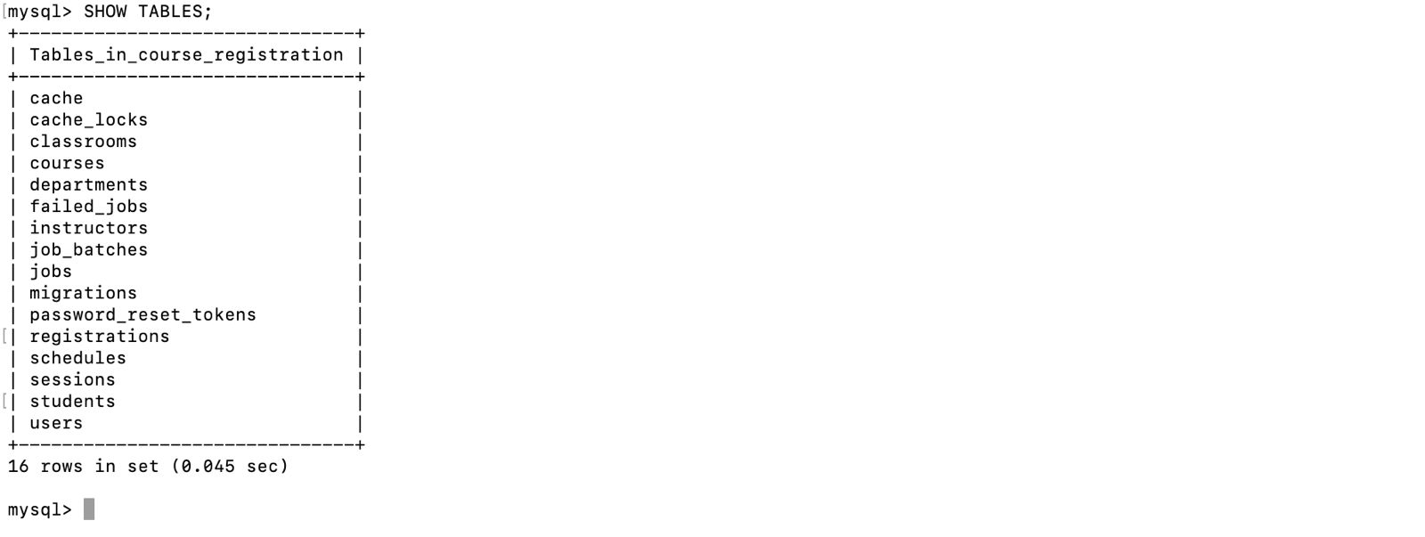

**TABLES:**

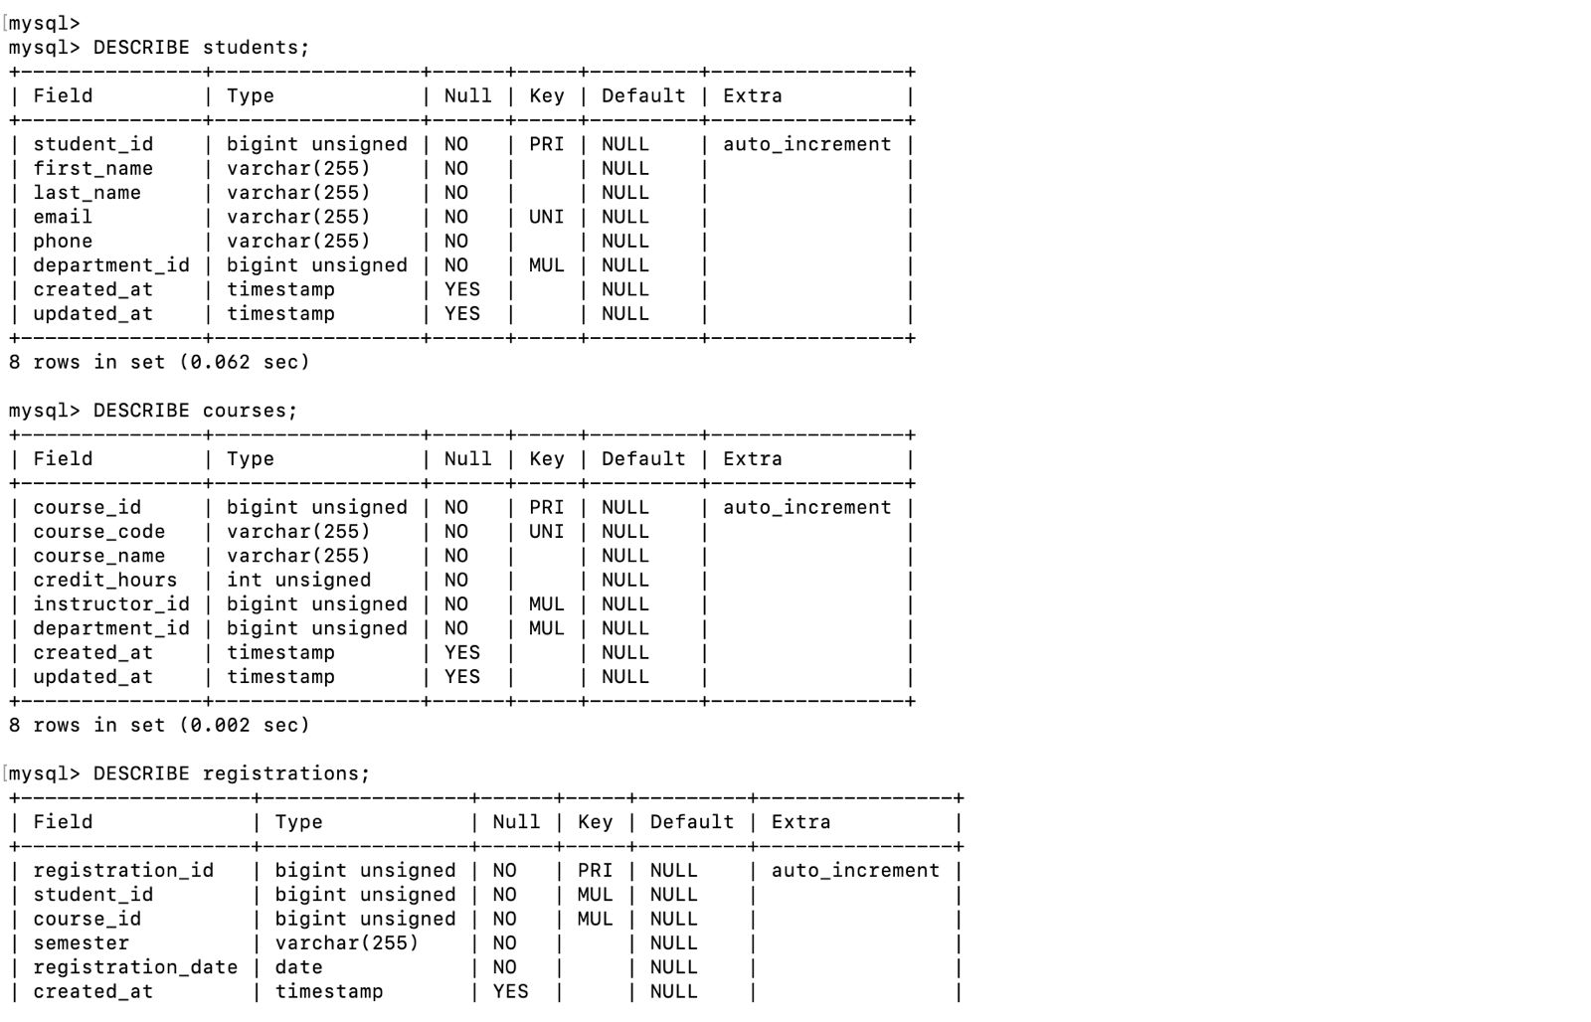

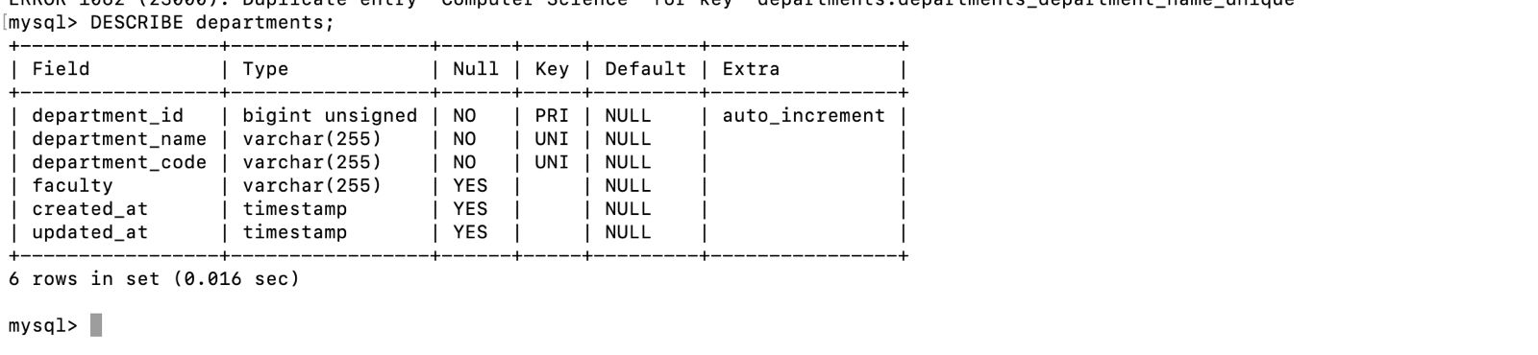

**METADATA:**

